Poster Presenters
- Joel Bonilla
  - Poster Position: 20
  - Title: Towards a preclinical model of comorbid alcohol and heroin addiction
- Victoria Chang
  - Poster Position: 19
  - Title: Reverse translation of a preclinical model of heroin addiction
- Nicholas Fayette
  - Poster Position: 15
  - Title: GABAergic and glutamatergic ventral pallidum neurons differentially encode motivation for heroin
- Ana Concalves
  - Poster Position: 14
  - Title: Instructive signals during locomotor adaptation
- Connor McCullough
  - Poster Position: 13
  - Title: Analysis of simultaneous in vivo two-photon imaging and extracellular electrophysiology using a novel head-mounted miniature microscope
- Carley Miller
  - Poster Position: 18
  - Title: A role for ventral pallidum glutamate neurons in the effects of stress on heroin sensitization
- Dr. Xioyu Peng
  - Poster Position: 12
  - Title: Vagus nerve stimulation modifies the neural representation of a skilled reach in motor cortex
- Brandi Wiedmeyer
  - Poster Position: 17
  - Title: Perineuronal nets in the ventral pallidum regulate relapse to heroin seeking
- Dane Winter
  - Poster Position: 16
  - Title: Screening the therapeutic efficacy of kappa opioid receptor agonists in a preclinical model of heroin addiction
- Kevin Zitelli
  - Poster Position: 11
  - Title: Dual color imaging in freely-behaving rodents using head-mountable one photon miniscope

Gather.town map
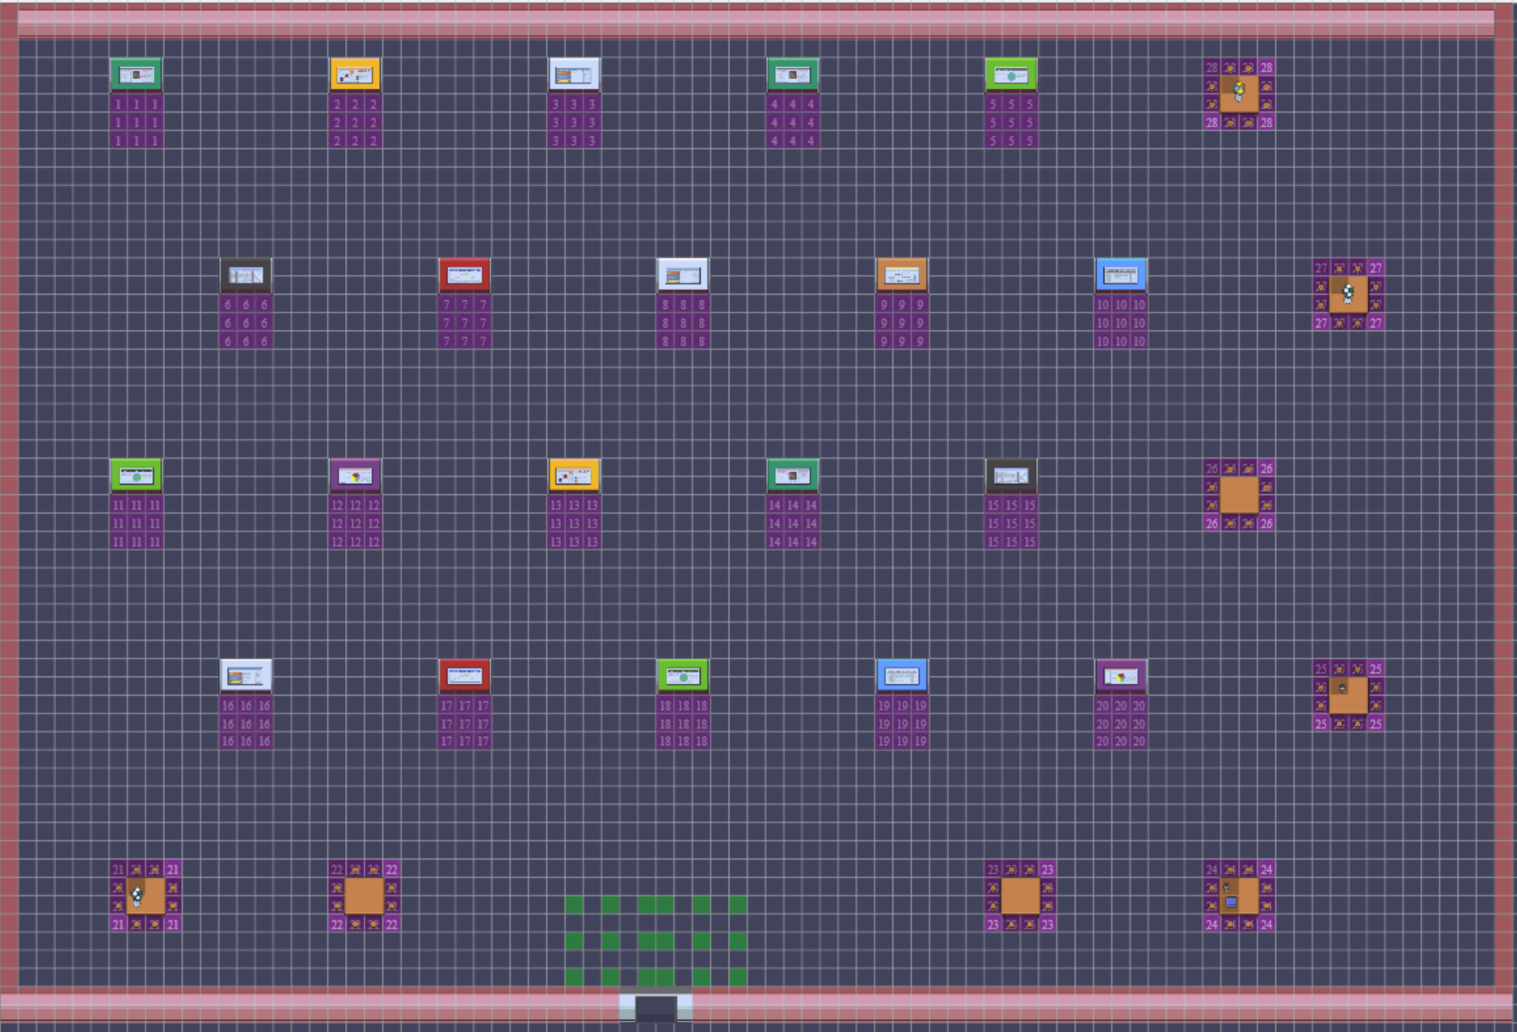
20
19
18
17
16
15
14
13
12
11
10
9
8
7
6
2
3
4
5
1

